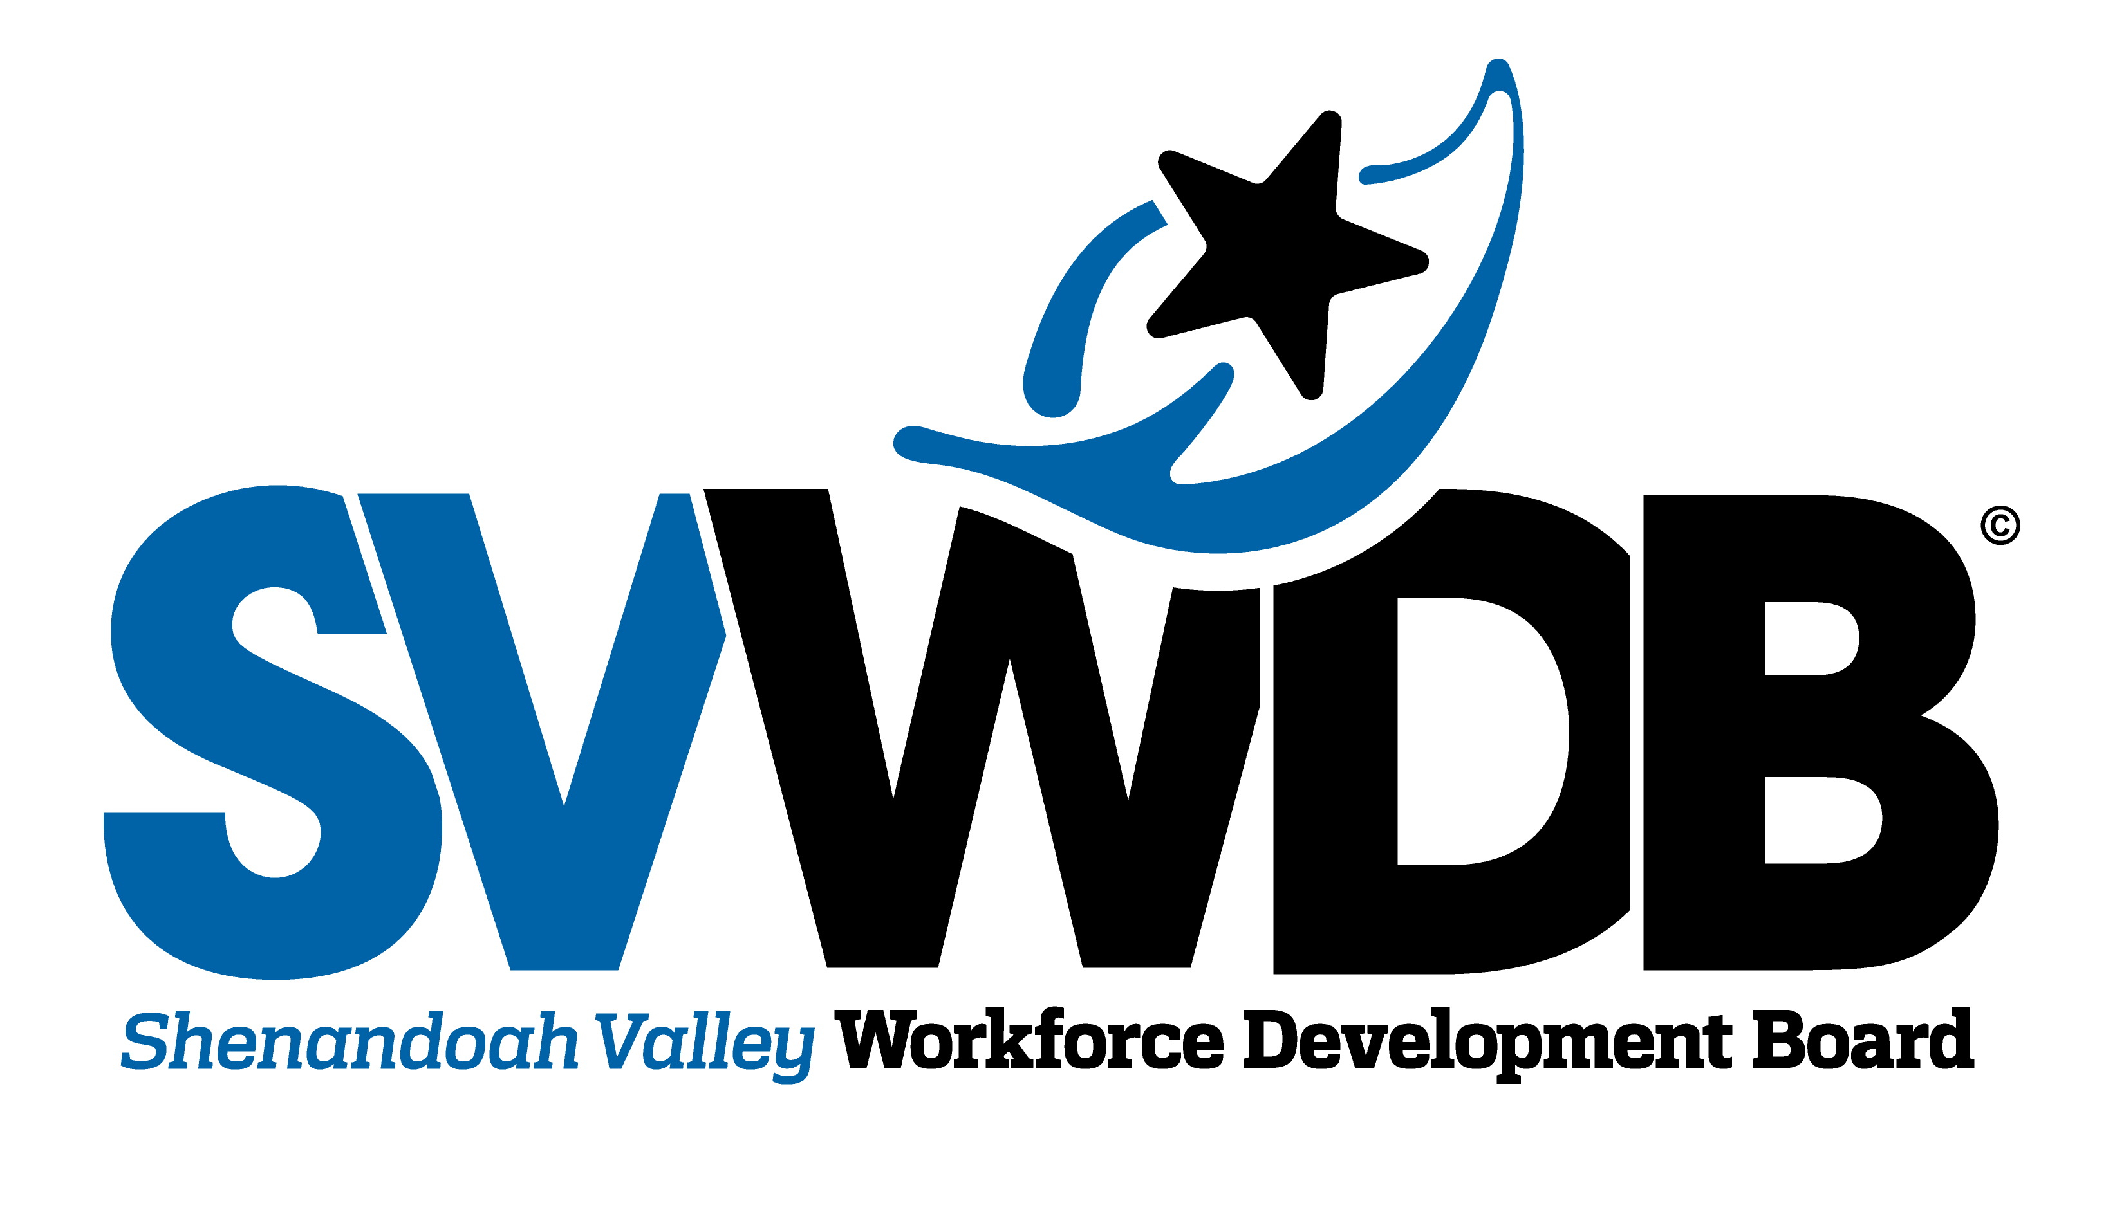

One Stop Operator RFP Pre-proposal Conference
February 11, 2022
Question & Answers

- For vendors who are applying to the RFP do they need to have experience in the Shenandoah Valley Area?
  - It could be helpful, however we frequently receive proposals from out of area vendors and we have worked with out of area vendors in the past.
- Is the expectation that the OSO be local and be on site 100% of the time, therefore preference is for a local provider?
  - The OSO is not limited to a local provider. It is expected that the OSO will be part time based on the funding and that the OSO will be scheduled to be present in person on regularly scheduled basis, but OSO responsibilities can be conducted using a combination of in-person and virtual options. The intent is that the OSO will not be a 100% virtual position and there will be in-person time as well.
- If that is not the expectation, it also states that travel is only reimbursable under the contract unless expressly preauthorized. Should the budget include travel, assuming that will be negotiated if awarded. Or should the budget not include travel/mileage and if the contract is awarded it will be negotiated and if approved, added to the contract?
  - Travel will be discussed and finalized during the negotiation process. If travel is planned as part of the design, explain the type of travel, the extend it will be used, and the budget. The intent was to make sure the OSO design did not include extensive weekly travel of airfare, hotel and meals as the core of the design. We received feedback from other local workforce boards where this type of design had been both a surprise, a problem, and a financial burden.
- Page 4 - B 4 refers to supporting daily operations of a partner integrated One Stop System. Does this refer to being on site to conduct center management functions?
  - There is a separate Center Manager on site to support facility management functions and separate from OSO responsibilities.
- Can supporting these daily operations be done both on site and virtually?
  - Yes, the OSO design can include a combination of on site and virtual operations..
- The proposal requirements appear to assume a fairly large organization that will assign multiple staff part time to a variety of admin functions (Page 7; D). The accounting requirements also seem to assume a large organization. As a sole proprietor, who does have staff and finance people, we pride ourselves that our responses identify the most senior level of the company to deliver 3 of the 4 bulleted services in part D. It appears as if that would be exclusionary. Is it?
  - No it is not exclusionary. Provide a design that demonstrates your ability to meet all of the bulleted services possible. Include if you are successfully providing these services now and meeting the requirements and how this is being accomplished.
Demographic Information

- Population: 533,253 – 7% annual growth 2010 - 2020
- Unemployment: 5.2% drop in unemployment since height of COVID
- Unemployment Rate: 2.7% down from height of 7.9% June 2020
- Labor Force Participation Age 16+: 61.2% age 16 years or older working
- Labor Force Participation Age 25-54: 82.2% age 25-54 years of age working
- Average Wages: $46,672 Up 9.2% over preceding four quarters (2021 Q1)
- Cost of Living: 1.4% higher than the national average (2021 Q1)
- Median Household Income: $ 60,927 (2021 Q1)
- Poverty Level: 16,972 households are receiving SNAP
- High School Graduates (age 25 – 64): 11.6% have no high school diploma
- Bachelor’s Degree or Higher: 27.1%, 19% have some college but no degree
- Target Industry Sectors:
- Manufacturing,
- Healthcare,
- Transportation and Logistics,
- Construction
- Education and Training:
- 9 public/private colleges and universities
- 3 community colleges
- 16 K-12 public school systems
- Numerous Career and Technical schools affiliated with the public school system
- Wilson Workforce and Rehabilitation Center
- Employer Concerns
- Recruitment and retention of employees
- Cannot find qualified applicants and the outlook is not promising
- Basic work skills, taken for granted but no longer taught
- Deliberate efforts to reach out and provide access to individuals who have been disenfranchised are necessary

