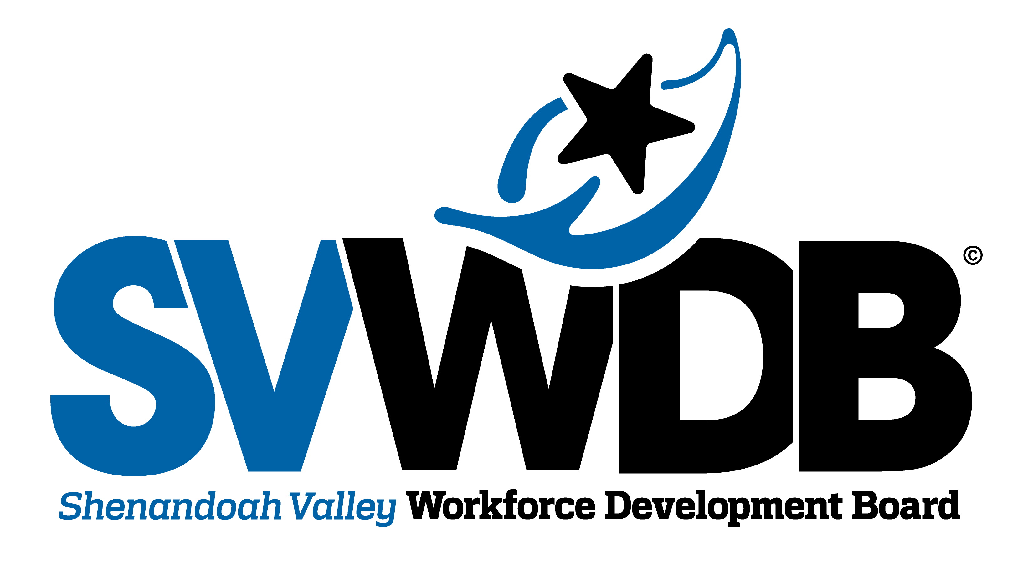

One Stop Operator RFP Pre-proposal Conference
February 11, 2022
Question & Answers

- For vendors who are applying to the RFP do they need to have experience in the Shenandoah Valley Area?
  - It could be helpful, however we frequently receive proposals from out of area vendors and we have worked with out of area vendors in the past.

Demographic Information

- Population: 533,253 – 7% annual growth 2010 - 2020
- Unemployment: 5.2% drop in unemployment since height of COVID
- Unemployment Rate: 2.7% down from height of 7.9% June 2020
- Labor Force Participation Age 16+: 61.2% age 16 years or older working
- Labor Force Participation Age 25-54: 82.2% age 25-54 years of age working
- Average Wages: $46,672 Up 9.2% over preceding four quarters (2021 Q1)
- Cost of Living: 1.4% higher than the national average (2021 Q1)
- Median Household Income: $ 60,927 (2021 Q1)
- Poverty Level: 16,972 households are receiving SNAP
- High School Graduates (age 25 – 64): 11.6% have no high school diploma
- Bachelor’s Degree or Higher: 27.1%, 19% have some college but no degree
- Target Industry Sectors:
- Manufacturing,
- Healthcare,
- Transportation and Logistics,
- Construction
- Education and Training:
- 9 public/private colleges and universities
- 3 community colleges
- 16 K-12 public school systems
- Numerous Career and Technical schools affiliated with the public school system
- Wilson Workforce and Rehabilitation Center
- Employer Concerns
- Recruitment and retention of employees
- Cannot find qualified applicants and the outlook is not promising
- Basic work skills, taken for granted but no longer taught
- Deliberate efforts to reach out and provide access to individuals who have been disenfranchised are necessary

